**Web &**

**Internet**

**Class Five**

**Lab 12**

|  |
| --- |
| Lab Objectives:  * Customizing Chrome |

# Customizing Chrome

## Another reason for Chrome's popularity is the customization it offers users. In this lesson, we'll talk about the many great features of Chrome that you can modify, including Chrome's start up options and the Chrome Web Store, which allows you to add applications, extensions, and themes to Chrome.

# Choosing your start up options

### To choose a homepage:

## By default, Chrome will show the New Tab page whenever you start the browser. If you'd like to see a specific website each time you open your browser, like a news site or weather forecast, you can set that site as your homepage.

## Click the Chrome menu in the top-right corner of the browser, then select Settings.

## IMG_256

## The Settings tab will appear. Locate and click the check box next to Show Home button.

## IMG_257

## By default, Chrome will open the New Tab page whenever you click the Home button. To choose a new homepage, click Change.

## IMG_258

## A dialog box will appear. Select Open this page: and type a web address. In our example, we'll type [www.cnn.com](http://www.cnn.com" \t "/home/deepto/Documents\\x/_blank).

## Click OK to continue.

## IMG_259

## The homepage will appear whenever you start Chrome. Click the Home button in the navigation bar to visit your homepage at any time.

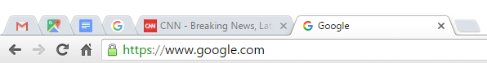

### To set Chrome as the default browser:

## If you would like to use Chrome as your only web browser, you can set it as the default browser on your computer. If you click a link in another program on your computer, like an email client, it will open in Chrome.

## Click the Chrome menu in the top-right corner of the browser, then select Settings.

## IMG_256

## The Settings tab will appear. Scroll down and select Make Google Chrome the default browser. Any link you open on your computer will now open in Google Chrome.

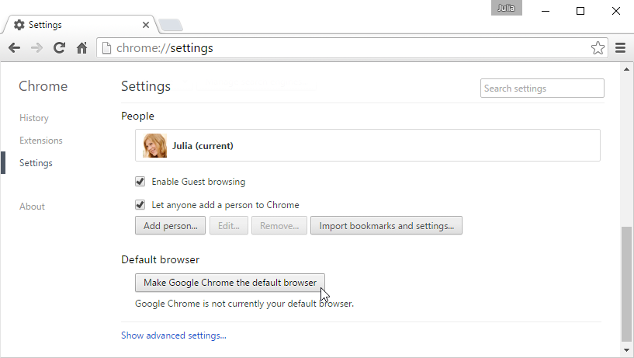

# The Chrome Web Store

## The Chrome Web Store allows you to download different web apps, extensions, and themes, which can make Chrome even more powerful and personal.

# Apps

## Web apps work just like software you might install on your computer, but they run through your browser instead of your operating system. Web apps range from simple tools like a calculator or notepad to complex applications like a photo editor or even a game!

### To install an app:

## Navigate to [https://chrome.google.com/webstore](https://chrome.google.com/webstore" \t "/home/deepto/Documents\\x/_blank).

## IMG_256

## The Chrome Web Store will appear. Click an app to learn more about it.

## IMG_257

## The app page will appear with information on how the app works, user reviews, screen shots, and more. If you want to use the app, click Add to Chrome.

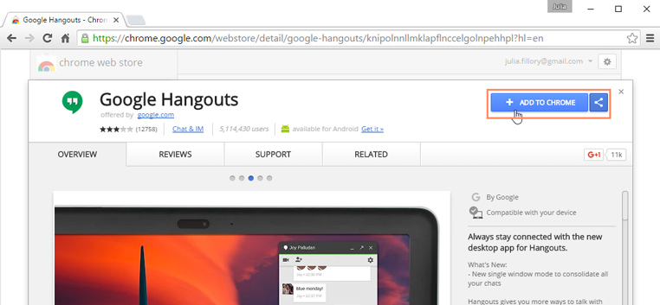

## A dialog box will appear. Click Add app to install the app.

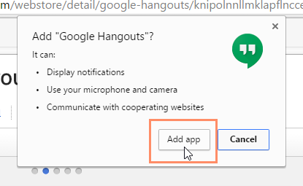

## The Apps page will appear with the installed app. Click the icon to start the app.

## IMG_260

## Depending on the app, it will open in either a new tab or window.IMG_261